7.0.17 Editors - 3D View - Armature - Edit Mode - Armature context menu
Edit Mode - Armature Context Menu 3
Subdivide 3
Last Operator Subdivide Multi 3
Number of Cuts 3
Duplicate 3
Last Operator Duplicate 3
Duplicate Objects 3
Flip Names 3
Move X , Y , Z 3
Orientation 3
Proportional editing 4
Extrude 4
Last Operator Extrude 4
Forked 4
Move X , Y, Z 4
Orientation 4
Proportional editing 4
Fill between Joints 5
Mirror 5
Interactive Mirror 5
X Global, Y Global etc. 5
Last Operator Mirror 5
Orientation 5
Constraint Axis 5
Proportional editing 5
Proportional Falloff 5
Proportional Size 6
Connected 6
Projected(2D) 6
Snap 6
Last Operator Snap 6
Offset 6
Switch Direction 6
Symmetrize 6
Last Operator Symmetrize 7
Direction 7
Names 7
Autoname Left/Right 7
Autoname Front/Back 7
Autoname Top/Bottom 7
Last operator Autoname by Axis 7
Axis 7
Flip Names 7
Last operator Autoname by Axis 7
Strip Numbers 7
Make Parent 8
Connected 8
Keep Offset 8
Last Operator Make Parent 8
Parent Type 8
Clear Parent 8
Clear Parent 8
Disconnect Bone 8
Last Operator Clear Parent 8
Clear Type 8
Split 9
Separate 9
Dissolve selected bones 9
Delete selected bones 9

Edit Mode - Armature Context Menu
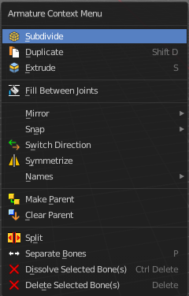
Call this menu with double right click in the 3D viewport. You need to be in Edit mode with a armature object.

Subdivide
Subdivide subdivides the current selection.

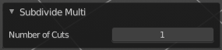
Last Operator Subdivide Multi

Number of Cuts
Adjust the number of subdivisions.

Duplicate
Duplicates selected bones.
You are automatically in grab mode, and so you can easily move the object out of position. Which is sometimes wanted, since you can position the duplicate then. But sometimes this is unwanted. A right click after releasing the mouse lets the object snap back into its creation position.
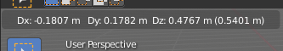
When you drag the duplicate around you will see the position values in the header.

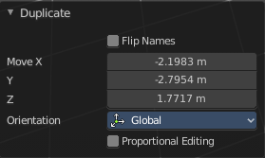
Last Operator Duplicate

Duplicate Objects

Flip Names
Tries to flip the names of the bones. This is a name convention feature. When you have a bone called mybone.R, then it tries to become mybone.L

Move X , Y , Z
The Position of the duplicated object.

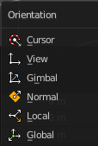
Orientation
Orientation is a drop-down box choose the type of orientation for the duplicate action.

Proportional editing

This checkbox has no use here. You cannot activate it.

Extrude
Extrudes out a bone from the selected joints.

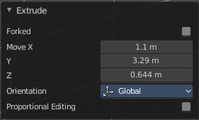
Last Operator Extrude

Forked
You need to tick X Axis Mirror. When you tick Forked, then the bone that you extrude to the one side will now be extruded to the other side too. The extrude gets mirrored along the x axis. This allows you to create a symmetrical armature.
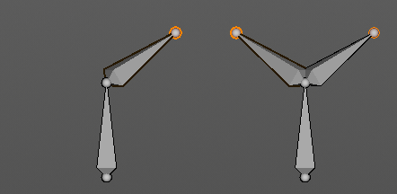
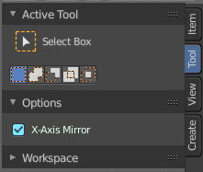

Move X , Y, Z
The transform values for the new created joint(s)


Orientation
Orientation is a drop-down box choose the type of orientation for the mirroring action.

Proportional editing
Proportional editing is dysfunctional. You cannot activate it.

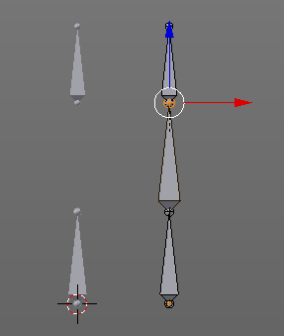
Fill between Joints
Fill between joints fills a bone between two selected joints.
When there is just one joint selected, then the bone is created between this selected joint and the 3D cursor.

Mirror
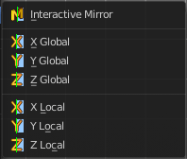
Mirror mirrors the selected geometry along the defined axis.

Interactive Mirror
Mirror by hotkeys. You activate the tool, type in x for x global for example, or x x for x local. And the selection gets mirrored.

X Global, Y Global etc.
Mirrors the selection around the chosen axis.

Last Operator Mirror

The Last Operator Mirror panel gives you tools to adjust the mirror action.

Orientation
Orientation is a drop-down box choose the type of orientation for the mirroring action.

Constraint Axis
Constraint Axis gives you again the possibility to define the mirror axis. You can choose more than one axis here.

Proportional editing
Enables proportional editing. Activating proportional editing reveals further settings.

Proportional Falloff
Adjust the falloff methods.

Proportional Size
See and adjust the falloff radius.

Connected
The proportional falloff gets calculated for connected parts only.

Projected(2D)
The proportional falloff gets calculated in the screen space. Depth doesn't play a role. When it's in the radius, then it gets calculated.


Snap
Choose several methods to snap one element to another. The menu items should be self explaining.

Last Operator Snap

Some snap operations shows a last operation panel, some not.

Offset
If the selection should snap as a whole, or if each individual element of the selection should snap.

Switch Direction
Switches the direction in which the selected bones are pointing.

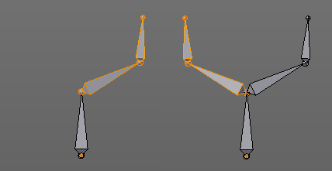
Symmetrize
Creates a symmetrical mirrored copy of the currently selected bones along the X axis. The mirror center is the pivot of the armature.

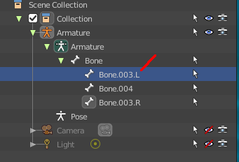
The bones that you want to symmetrize needs to follow the left right name conventions for bones. Bones without this left right naming are not affected by the tool. If there is a lower or upper case “L”, “R”, “left” or “right” with a separating dot in the bone name, then this tool creates and renames the bones names to its counter part. Bone.L becomes Bone.R.

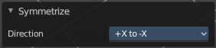
Last Operator Symmetrize

Direction
Define the calculation direction. From -X to + X or from +X to -X

Names
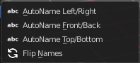
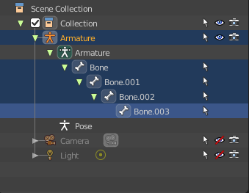
Bforartists has some internal name conventions for a symmetrical armature. Bones are for example named mybone.L or mybone.R, dependent at which side of the mirror axis they are. The Names items allows you to rename the bone names to this name convention.

Autoname Left/Right
Renames the bones from left to right.

Autoname Front/Back
Renames the bones from front to back.

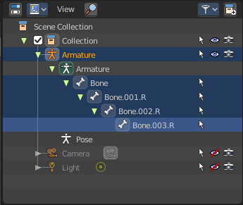
Autoname Top/Bottom
Renames the bones from top to bottom.

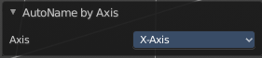
Last operator Autoname by Axis

Axis
Choose the autoname axis again. Left/Right is X axis, Front/Back is Y axis, and Top/Bottom is Z axis.

Flip Names
When you mirror a half of an armature you end in names like Bone.001.R.001. But what we need is Bone.001.L for a symmetrical armature. Flip names flips the names to follow the left right name conventions.

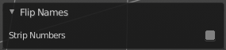
Last operator Autoname by Axis

Strip Numbers
Tries to remove the numbers in the names if possible.

Make Parent
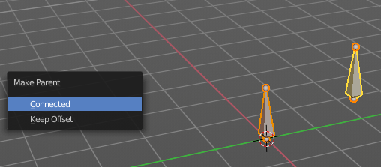
Adds a parent relationship.
Select a bone, hold down shift, select the bone that you want to parent it to. Perform Make Parent. In the popup choose the method that you want to use.

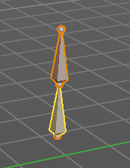
Connected
The child bone will jump to the position of the tail joint of the parent bone.

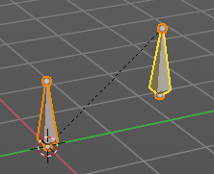
Keep Offset
The bone will remain in its original position. The relationship will be displayed by a black dotted line.

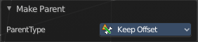
Last Operator Make Parent

Parent Type
Choose between Connected and Keep Offset method again.

Clear Parent
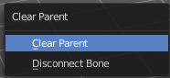
Clears the parent relationship of the selected bone(s). It calls a popup menu choose between two methods.

Clear Parent
Clears the parent relationship of the selected bone(s).

Disconnect Bone
The parent-ship is kept. Turns a Connected parent relationship into a Keep Offset parent relationship. You can move the disconnected bone around without to pull the parent with it.

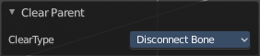
Last Operator Clear Parent

Clear Type
Choose between Clear Parent and Disconnect Bone method again.

Split
Split splits the selected bone(s) from connected bones. They are still part of the armature. But the bone is now floating. And you can pull this bone(s) around without pulling the rest of the armature around.
The Last operator for Split has no content.

Separate
Separate separates the selected bone(s) from the armature. And creates a new, independent, armature.
The Last operator for Separate has no content.

Dissolve selected bones
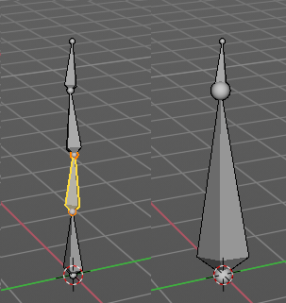
Merges the selected bone or joint with its hierarchical neighbor bones.

Delete selected bones
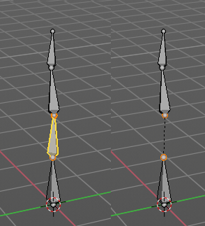
Deletes the selected bones. The hierarchy is kept. The involved bones becomes disconnected.

